
Rose Wine dataset
Business Report


By: Shubhank katarey
(PGP-DSBA)

TIME SERIES FORECASTING - ROSE WINE DATASET

Problem Statement:
For this particular assignment, the data of different types of wine sales in the 20th century is to be analyzed. Both of these data are from the same company but of different wines. As an analyst in the ABC Estate Wines, you are tasked to analyze and forecast Wine Sales in the 20th century.

1. Read the data as an appropriate Time Series data and plot the data.
Head of the data:
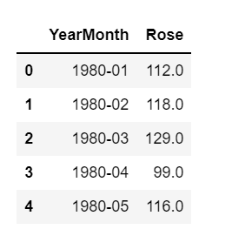

Tail of the data:
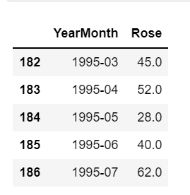

Description of the data:
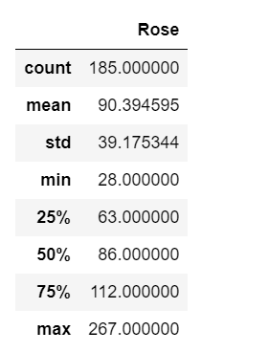
After converting it into the proper time series format, let’s look at the dataset again:
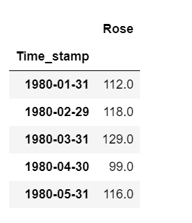
Plotting:
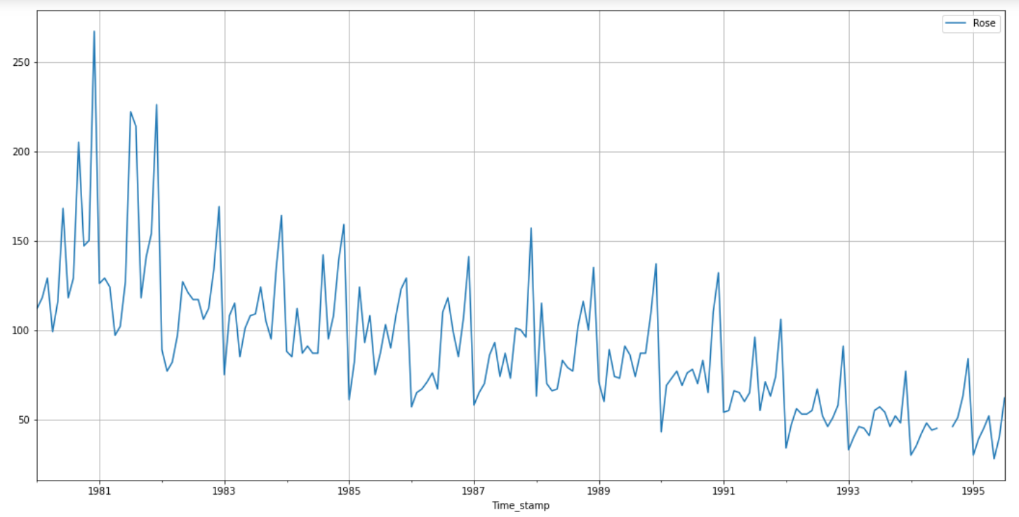

It is clearly visible that dataset has decreasing seasonality and trend. Also we can see that the year 1994 has the missing data
Now first we have to treat the missing observations in the dataset
We are using interpolation method to treat the missing observations. This interpolation method is to use a spline to connect the values. Using a spline interpolation requires you specify the order (number of terms in the polynomial). In our case, an order of 1 is just fine.

After using the spline method for interpolation, let’s look at the data plot again:

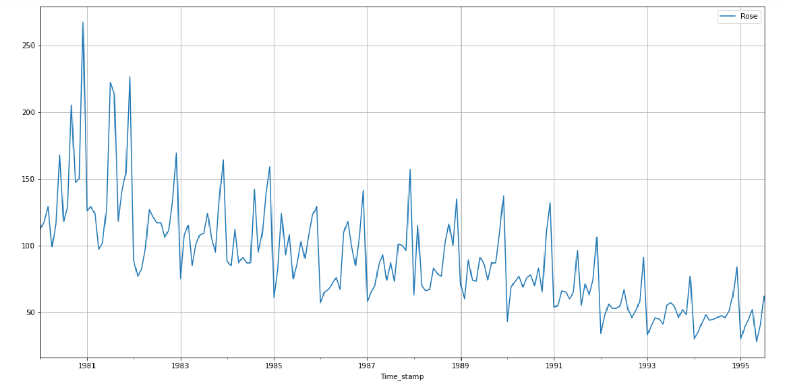
Now we can see there are no missing points observed in the above plot.
2. Perform appropriate Exploratory Data Analysis to understand the data and also perform decomposition.
Boxplot (Yearly):
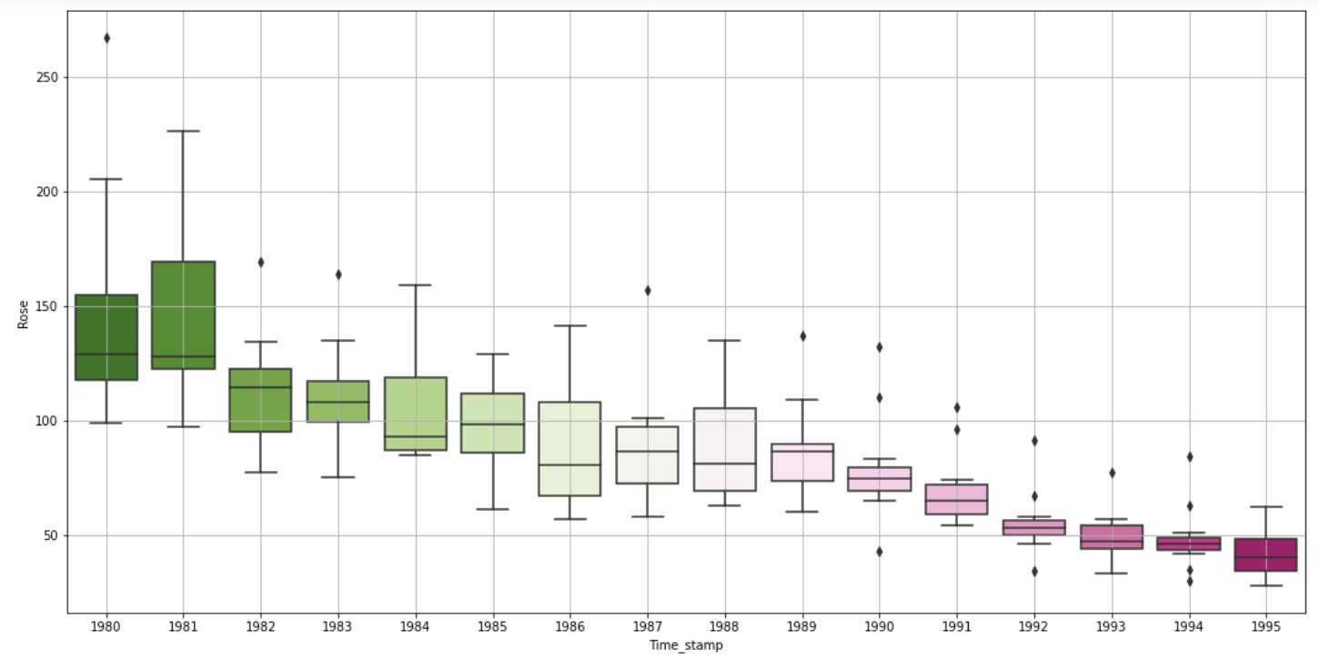

Boxplot (Monthly):
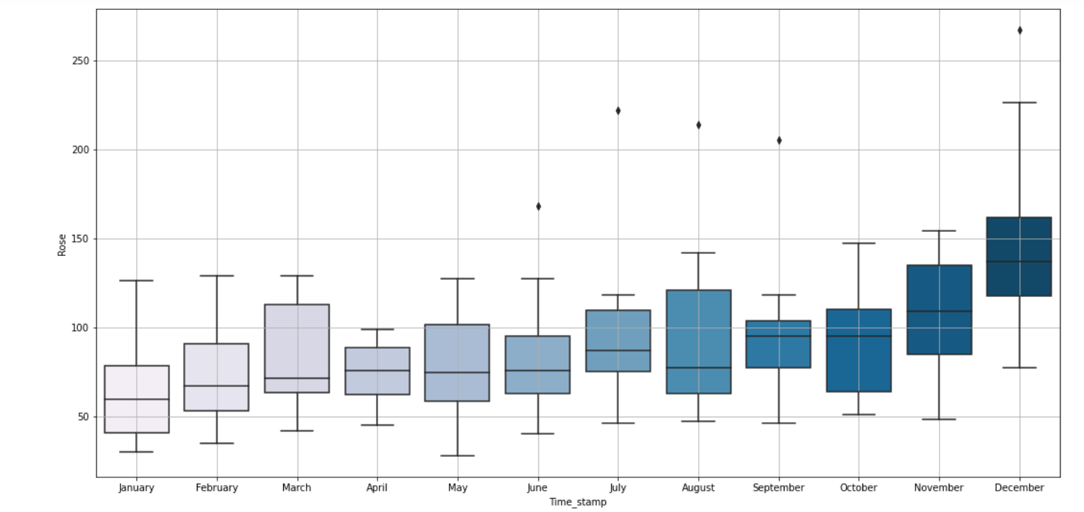

Month Wise sales per year:
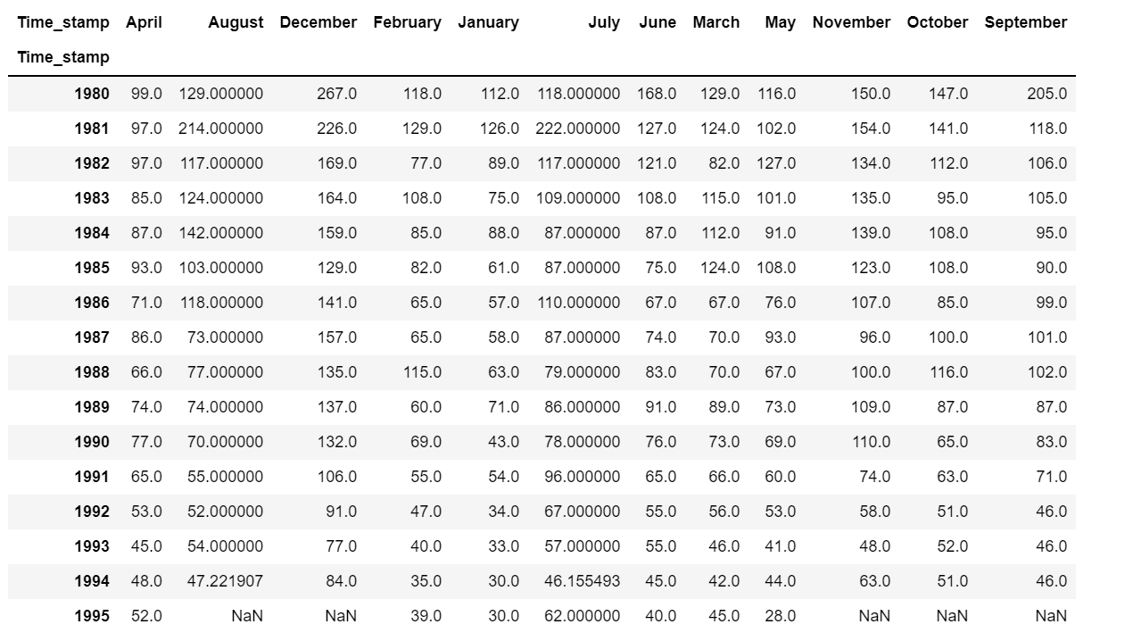

Let’s look at the plot for the same:
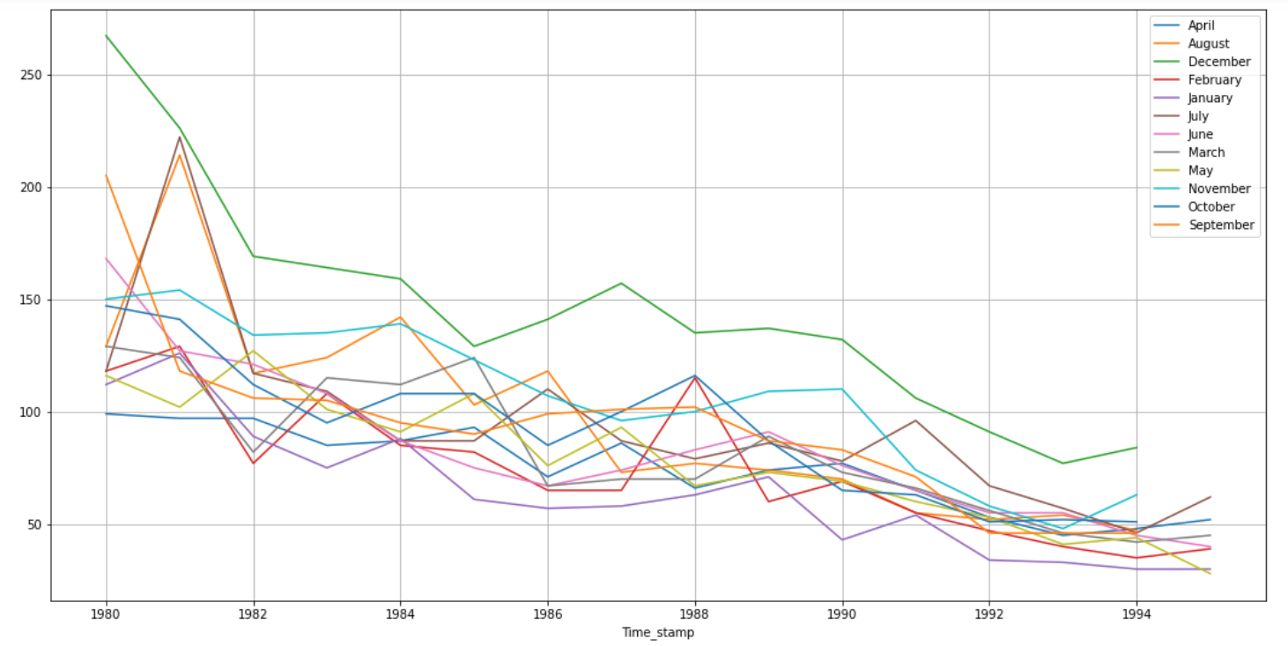

Additive Decomposition:

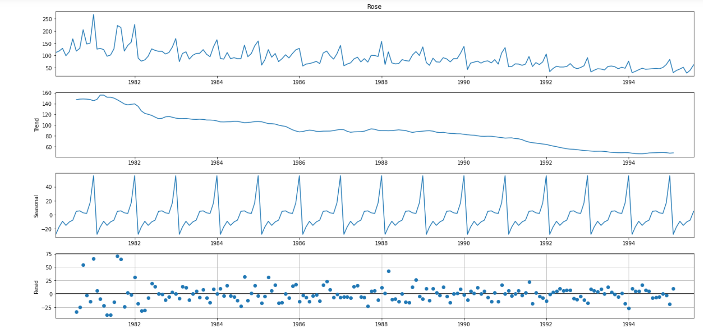

Multiplicative Decomposition:
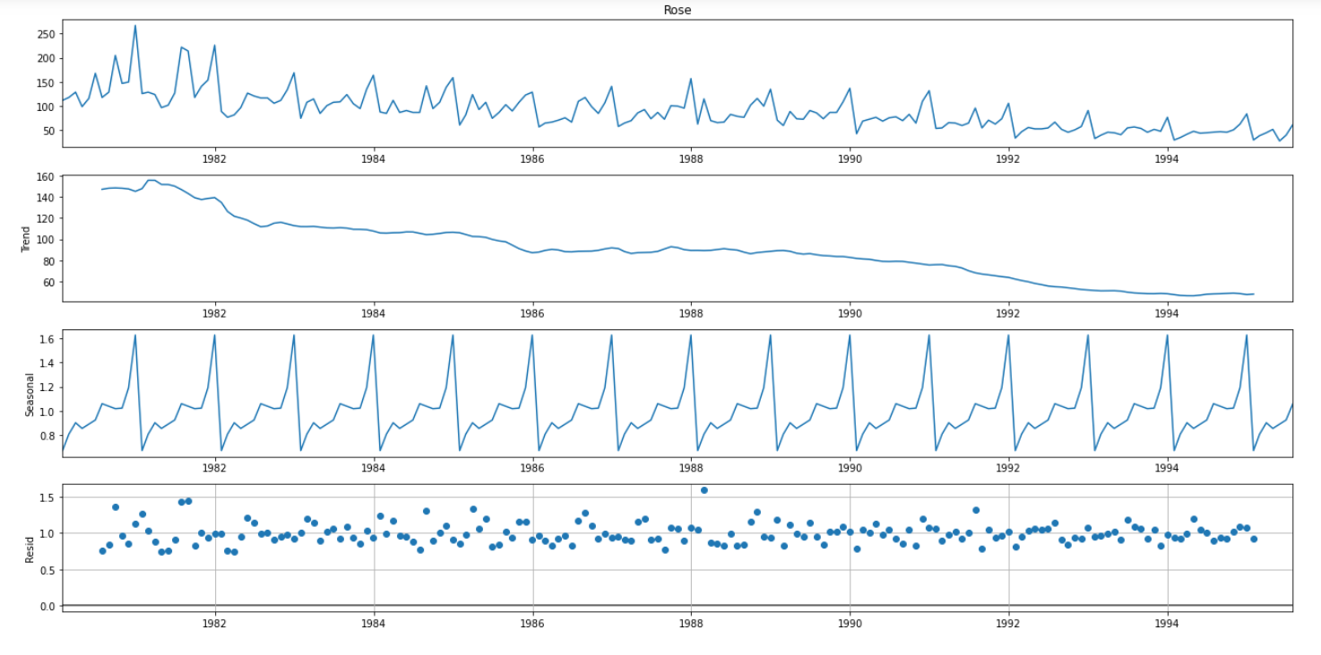

In the multiplicative model, residual still showing some patterns, so we will go with additive model.

3. Split the data into training and test. The test data should start in 1991.

Tail of the train set:
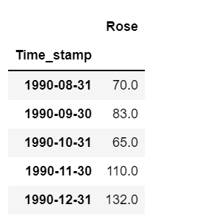

Head of the test set:
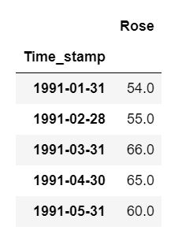
We can see that the train set has the records up to 1990 and from 1991 test set holds the records up to 1995.
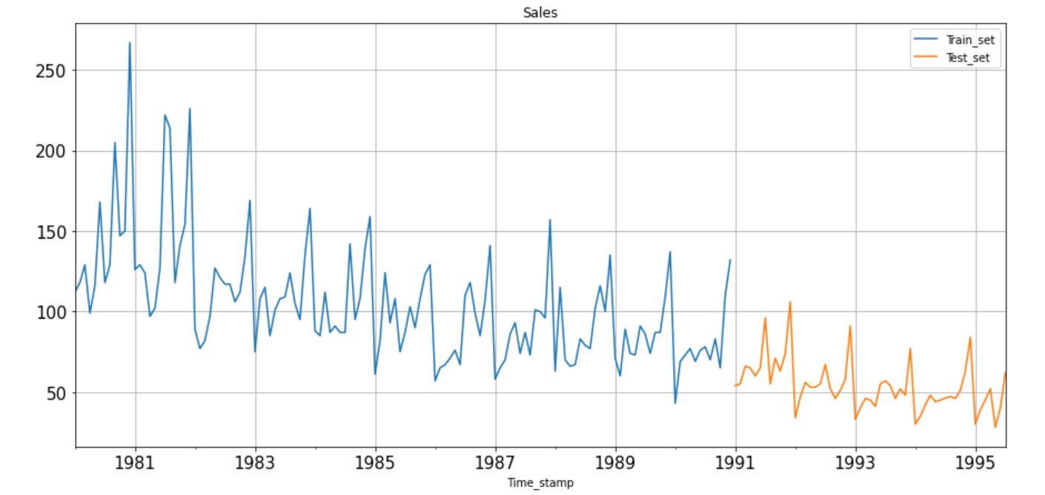

4. Build various exponential smoothing models on the training data and evaluate the model using RMSE on the test data. Other models such as regression, naïve forecast models, simple average models etc. should also be built on the training data and check the performance on the test data using RMSE.
Linear Model:
Let’s first make the time instance for train and test set:
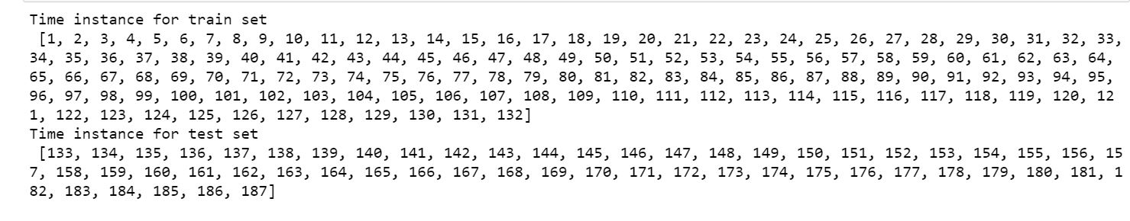
Head of train and test set for Linear Regression:
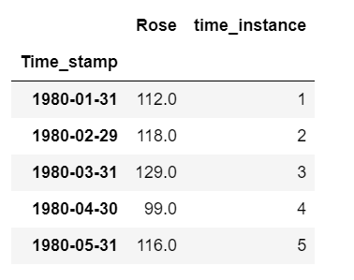

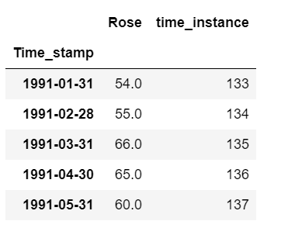

Plot for train and test set after fitting Regression on time on test set:
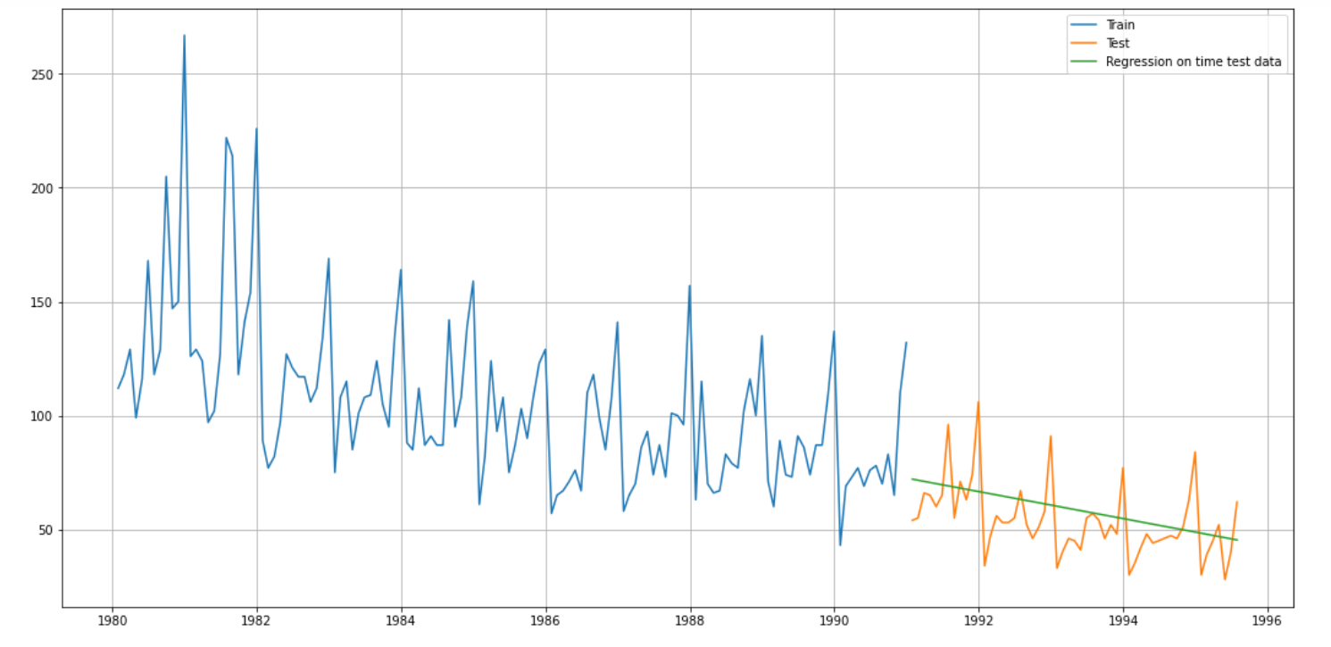

Calculation of RMSE value :
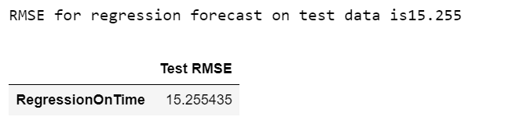

Naïve Model:
Naïve Forecast on test data:
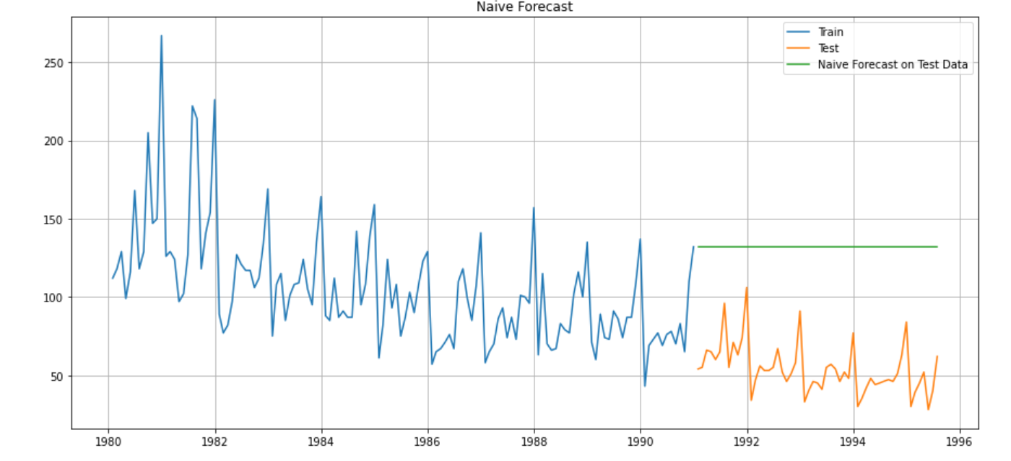

RMSE for naive model forecast on test data is 79.672

Simple Average Model:
Head of Simple Average Model with mean forecast:
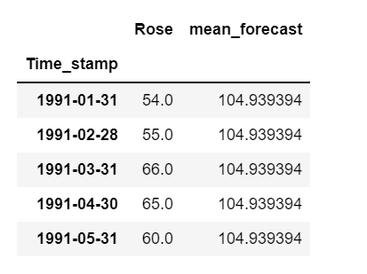

Plot for Simple Average Model forecast on test data:
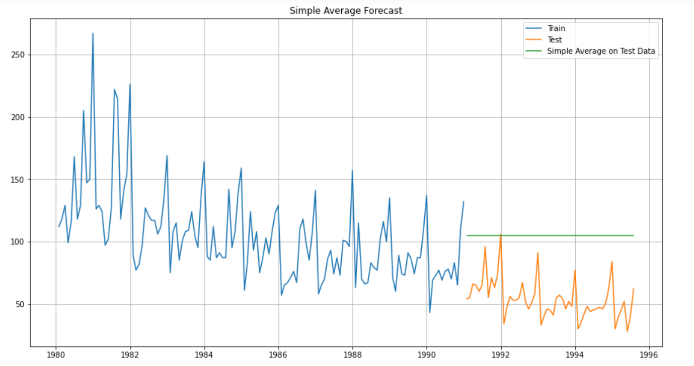

Calculation of RMSE:
RMSE for Simple average forecast on test data is 53.413

Moving Average Model:
For this model, we need to calculate moving averages for different intervals.
The best interval can be determined by the maximum accuracy with the minimum error.

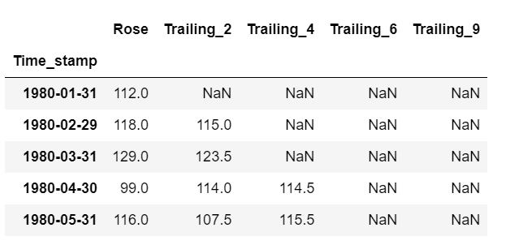
Plot for Moving Average model after calculating the 2 point trailing, 4 point trailing, 6 point trailing and 9 point trailing mean averages
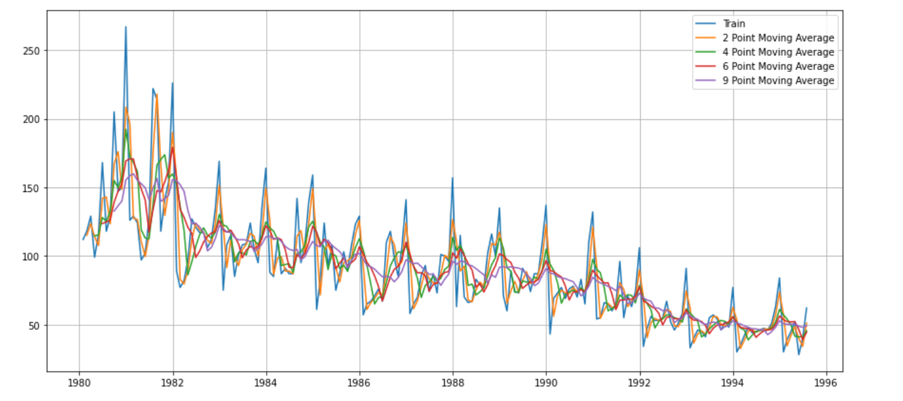
Plot after applying 2 point trailing, 4 point trailing, 6 point trailing and 9 point trailing mean averages on train and test set

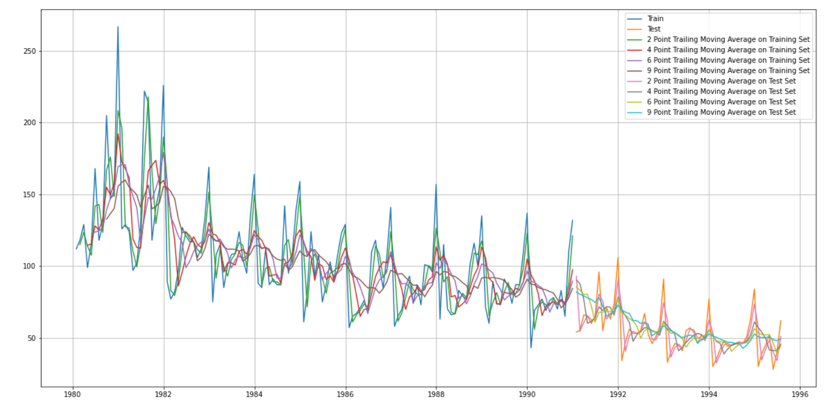

Evaluation of RMSE on train data for all trailing points:
For 2 point Moving Average Model forecast on the Training Data, RMSE value is 11.530
For 4 point Moving Average Model forecast on the Training Data, RMSE value is 14.444
For 6 point Moving Average Model forecast on the Training Data, RMSE value is 14.555
For 9 point Moving Average Model forecast on the Training Data, RMSE value is 14.721

From the above calculations, we can say that till now the best model seems to be 2 point moving average forecast model, with the lowest RMSE value of 11.530

Triple Exponential Smoothing model or Holt-Winter's model:
Since our data shows trend and seasonality patterns, it will good to use Triple Exponential smoothing model for this data.
After applying auto-fit to the model, we got the parameters as below:
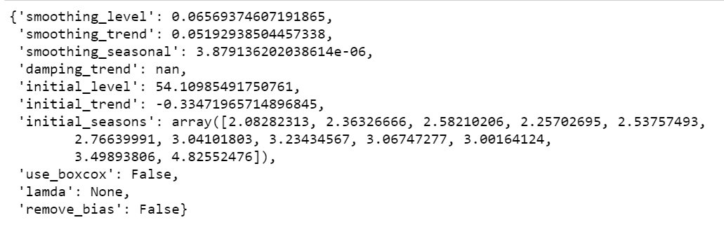
Prediction on test data:
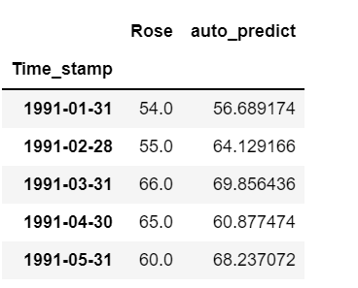

Plotting on test data using auto-fit:

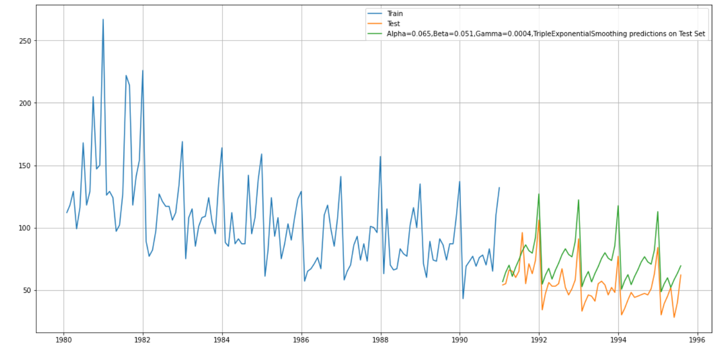

Calculation of RMSE on test data:
For Alpha=0.065, Beta=0.051, Gamma=0.0004, Triple Exponential Smoothing Model forecast on the Test Data, RMSE is 20.960
Let’s check the best RMSE values with the above parameters:
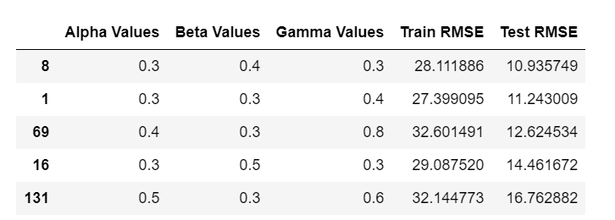

Calculation of RMSE values:
We can see that at alpha value 0.3, beta value 0.4 and gamma value 0.3, we are getting the lowest RMSE vale.
RMSE_TES_test_new_1 = 10.935749
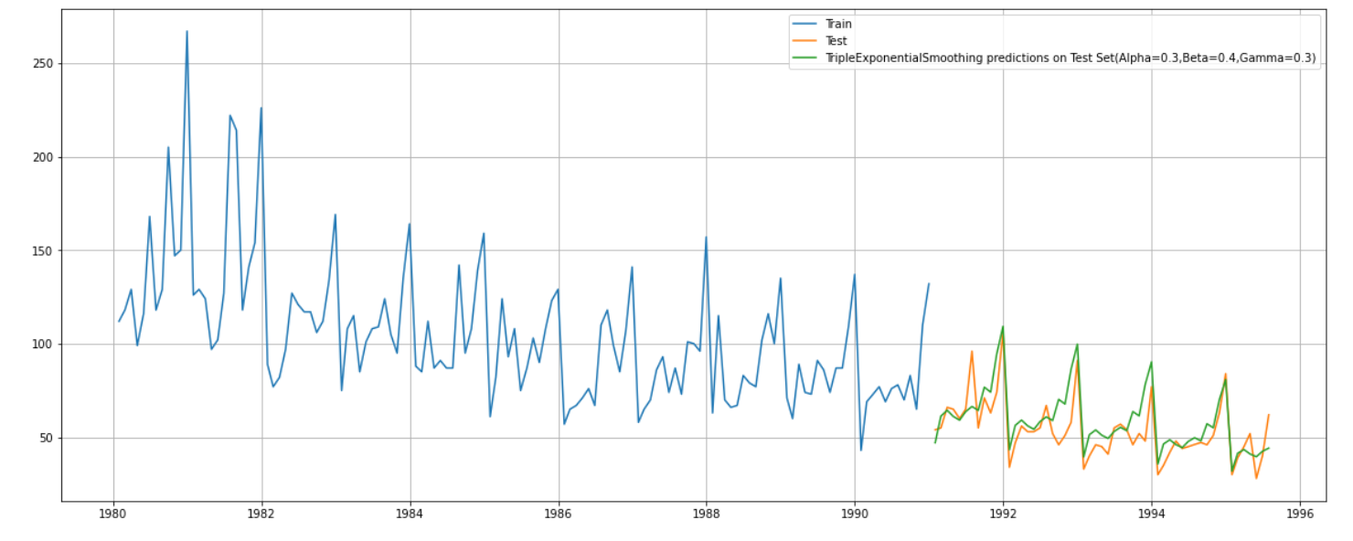
Triple Exponential Smoothing predictions on Test Set (Alpha=0.3, Beta=0.4, Gamma=0.3)
Green line on the plot shows the TES predictions on test set with best alpha, beta and gamma values.

5. Check for the stationarity of the data on which the model is being built on using appropriate statistical tests and also mention the hypothesis for the statistical test. If the data is found to be non-stationary, take appropriate steps to make it stationary. Check the new data for stationarity and comment. Note: Stationarity should be checked at alpha = 0.05.

We will check for the stationarity of the data by sing Dickey Fuller test
Dickey Fuller Test:
Taking Null Hypothesis 𝐻0 - Series is not stationary
Taking Alternative Hypothesis 𝐻1 - Series is stationary

After importing from adfuller from stats models, we have created a function to test the stationarity on the dataset.
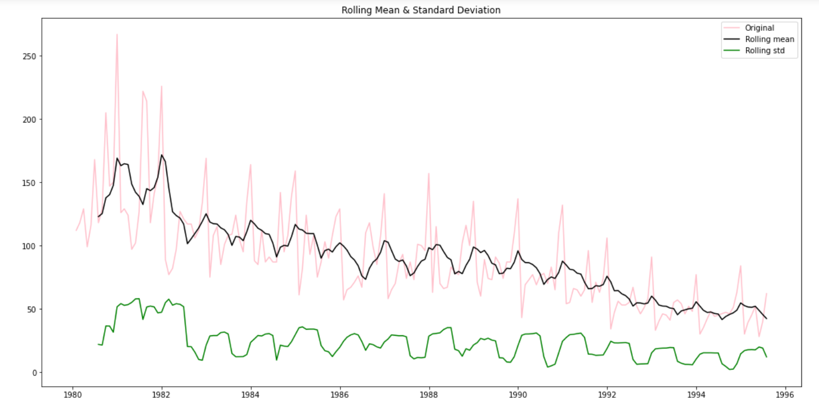

The above plot showing the rolling mean and standard deviation plot on the dataset.
We can see that the time series isn't stationary at 5% significant level, let's now check with difference of order 1.
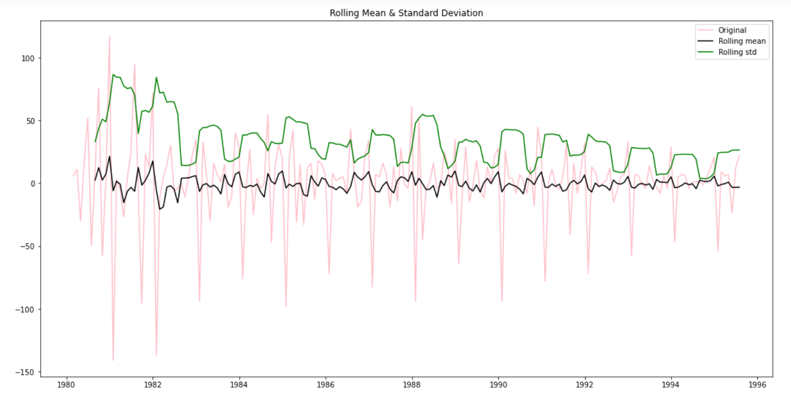
We can clearly see the difference between above plot and the previous plot.
Series is now stationary.
6. Build an automated version of the ARIMA/SARIMA model in which the parameters are selected using the lowest Akaike Information Criteria (AIC) on the training data and evaluate this model on the test data using RMSE.

Below are some of the combinations of parameters for the ARIMA model and the parameters are selected using the lowest Akaike Information (AIC) on the training data.

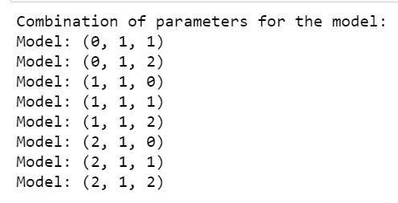
ARIMA model with AIC:
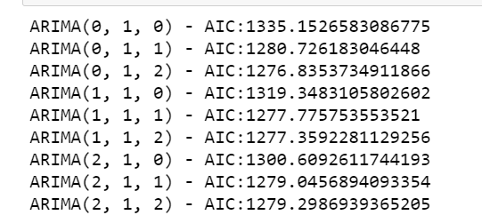
The lowest AIC value comes out to 1276.83 at ARIMA (0, 1, and 2).

Let’s look at the ARIMA model summary:
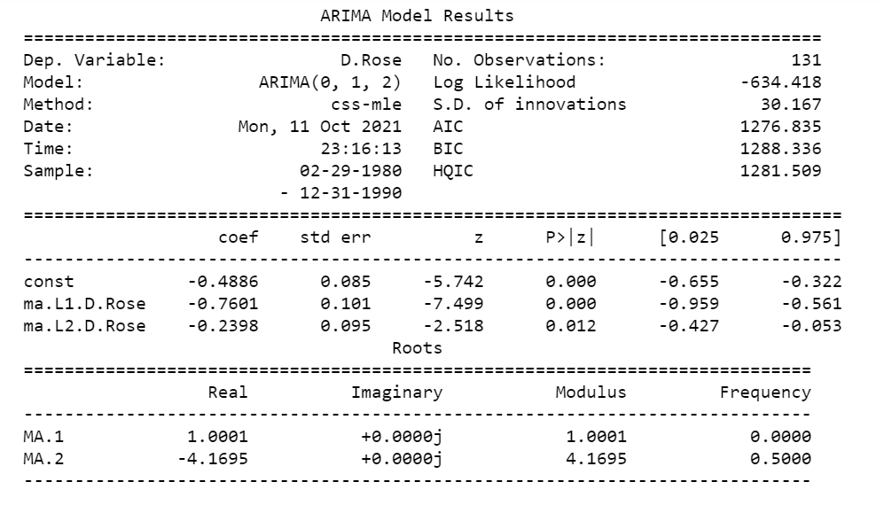
Calculation of RMSE: 15.60419552386519

Let’s now look at the combinations of parameters for the SARIMA model:
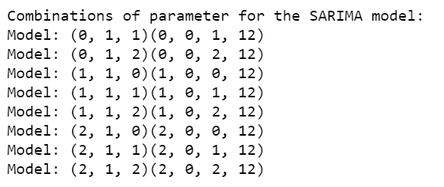

Using AIC:
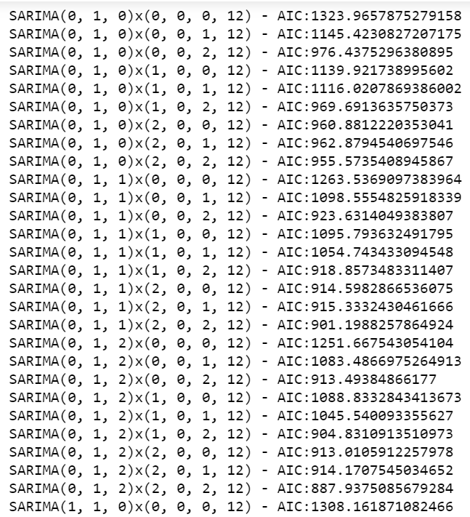
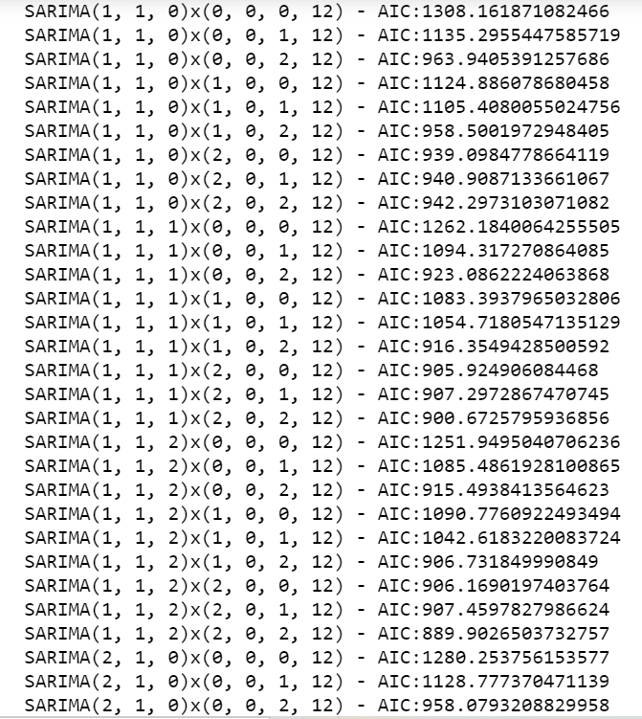
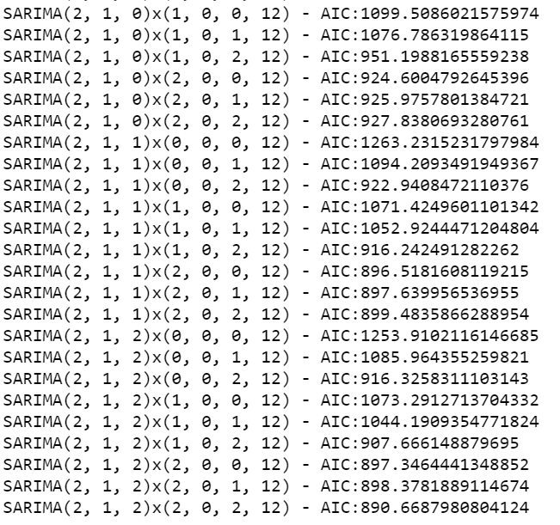
We have seen that the list is too long. So we will sort out the top 5 lowest values of the AIC:
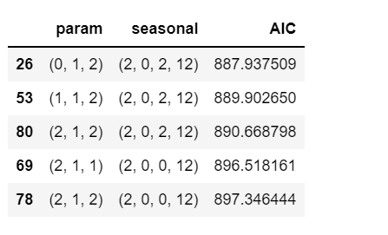

Let’s look at the SARIMAX summary points:
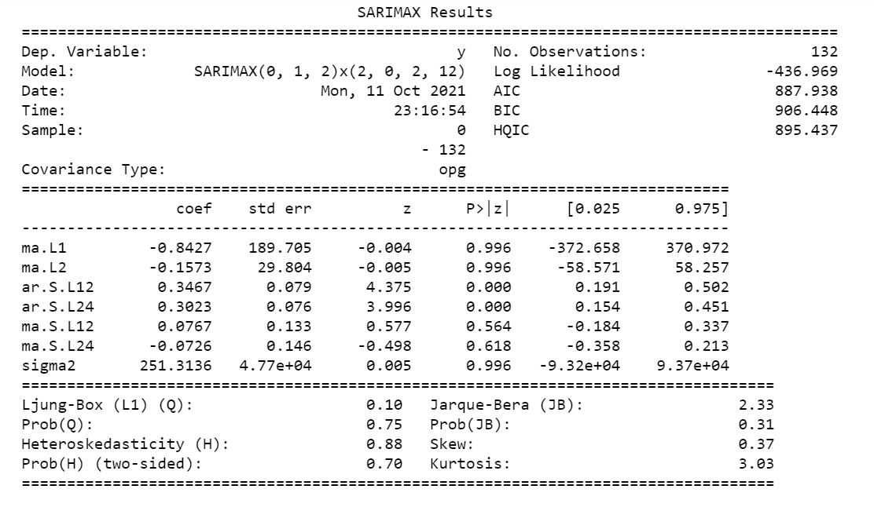

Diagnostics plot:
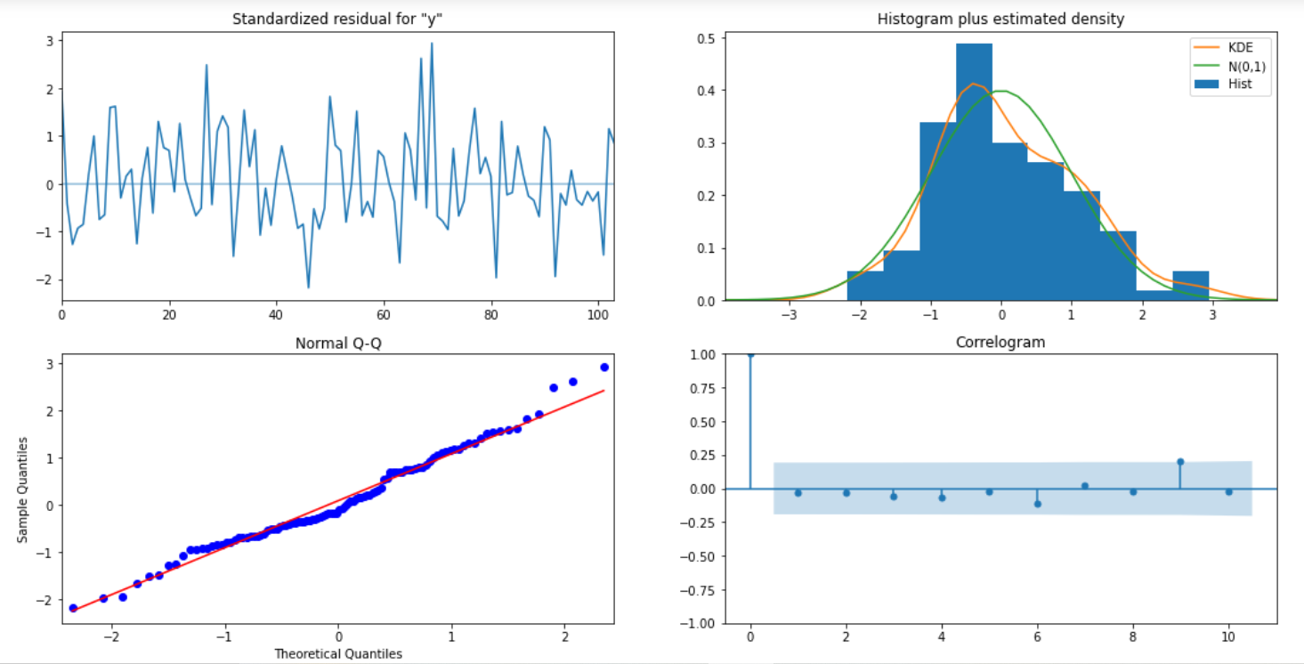

Predictions on test set:
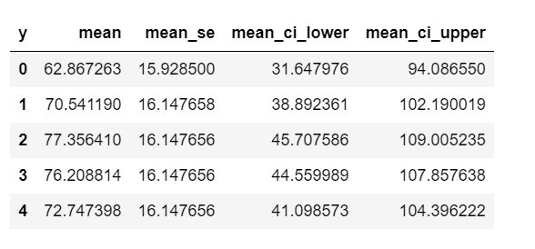
RMSE value on test data: 26.88062501761389

7. Build ARIMA/SARIMA models based on the cut-off points of ACF and PACF on the training data and evaluate this model on the test data using RMSE.
After importing ACF and PACF from stats models, let's plot the ARIMA/SARIMA models with cut off points of ACF and PACF on training data.

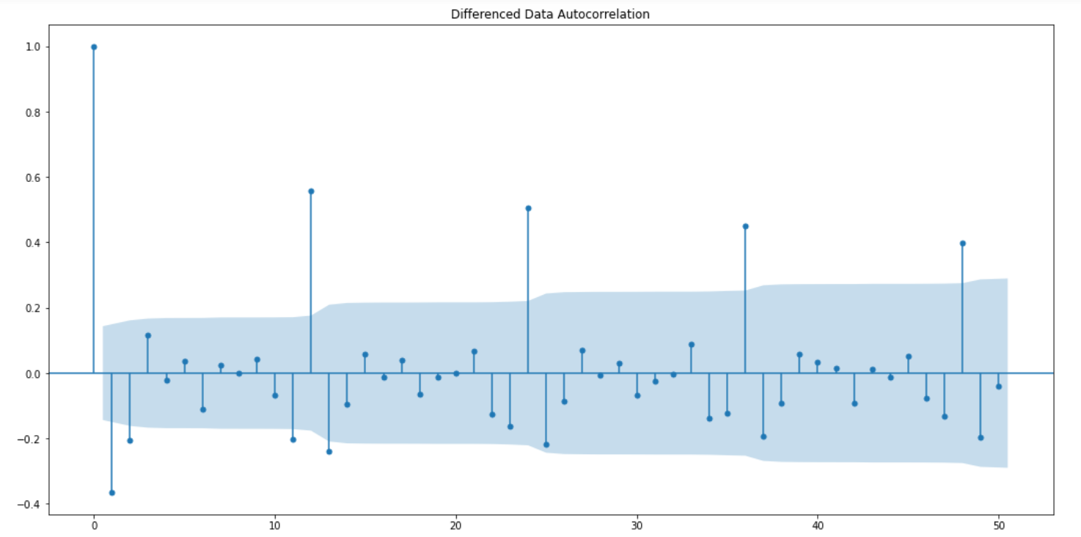

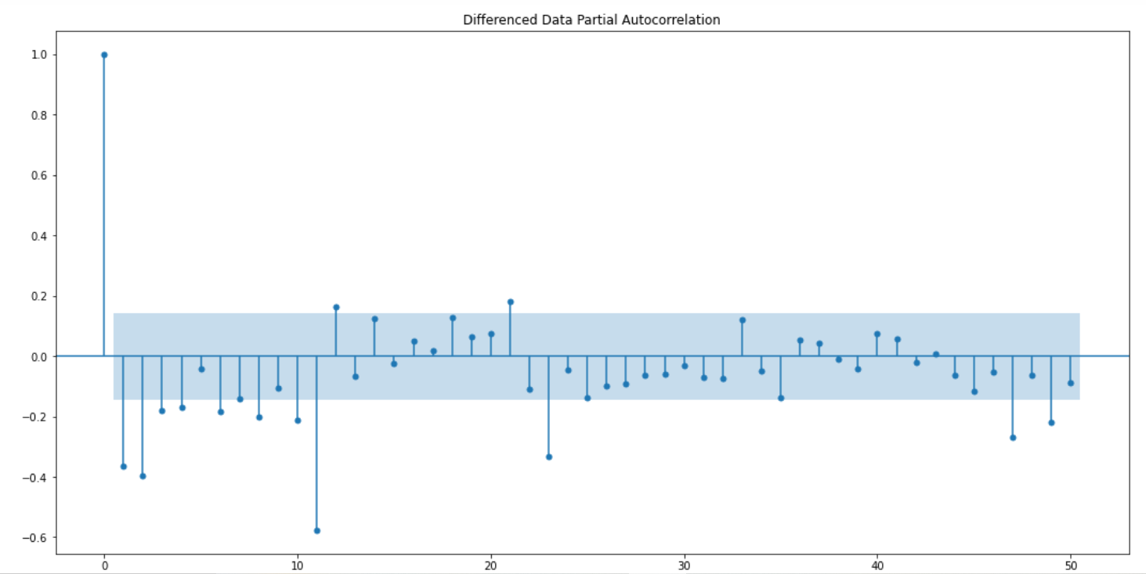

ARIMA model summary and results:

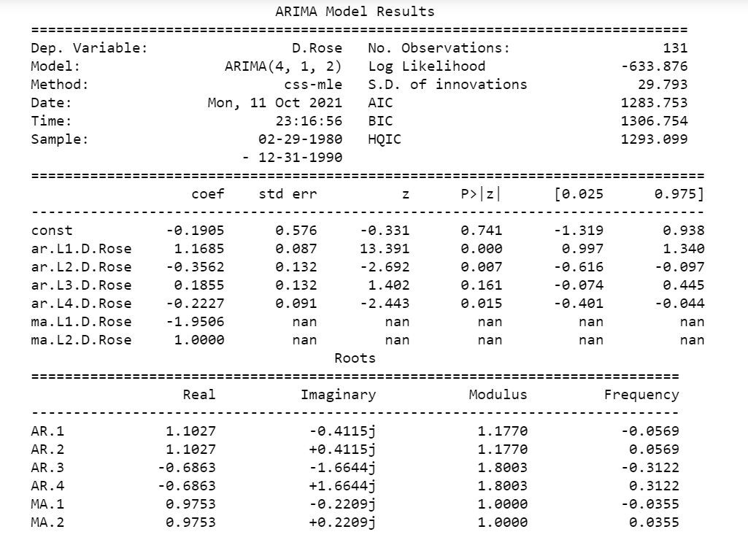
RMSE value on test data: 33.90482729155276

This is the original dataset plot:
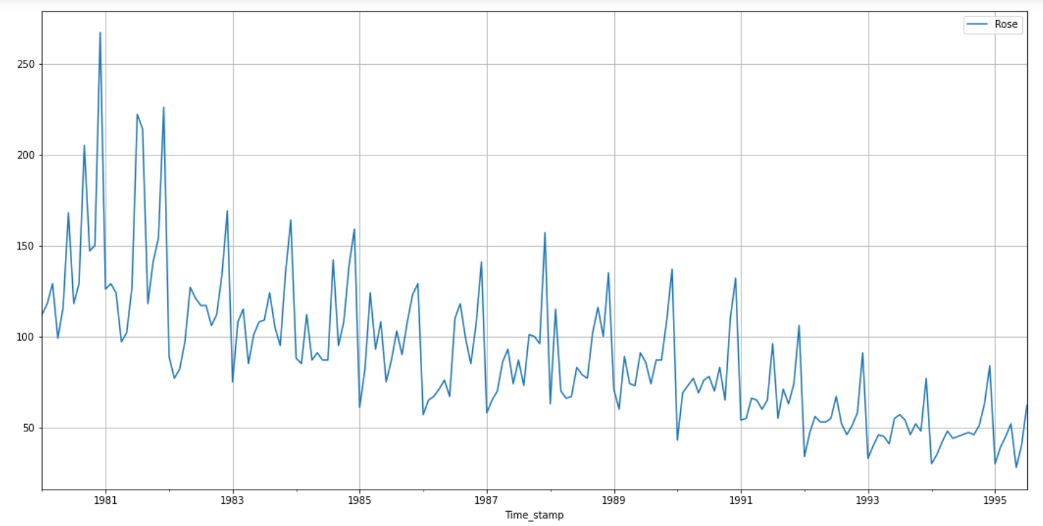

Let’s now look at the plot after applying differencing of 6:
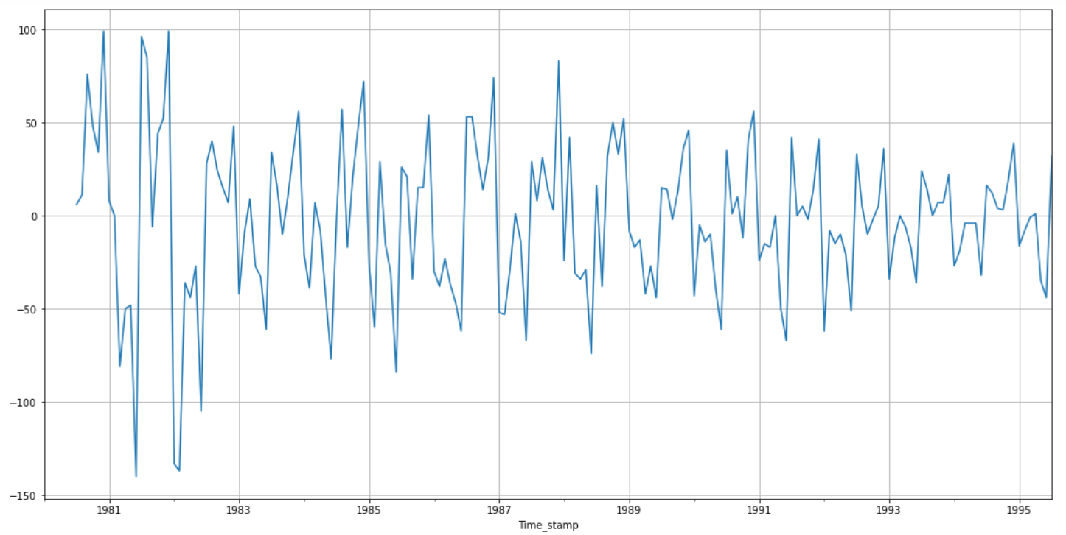

Now again taking the stationarity test for same differencing:
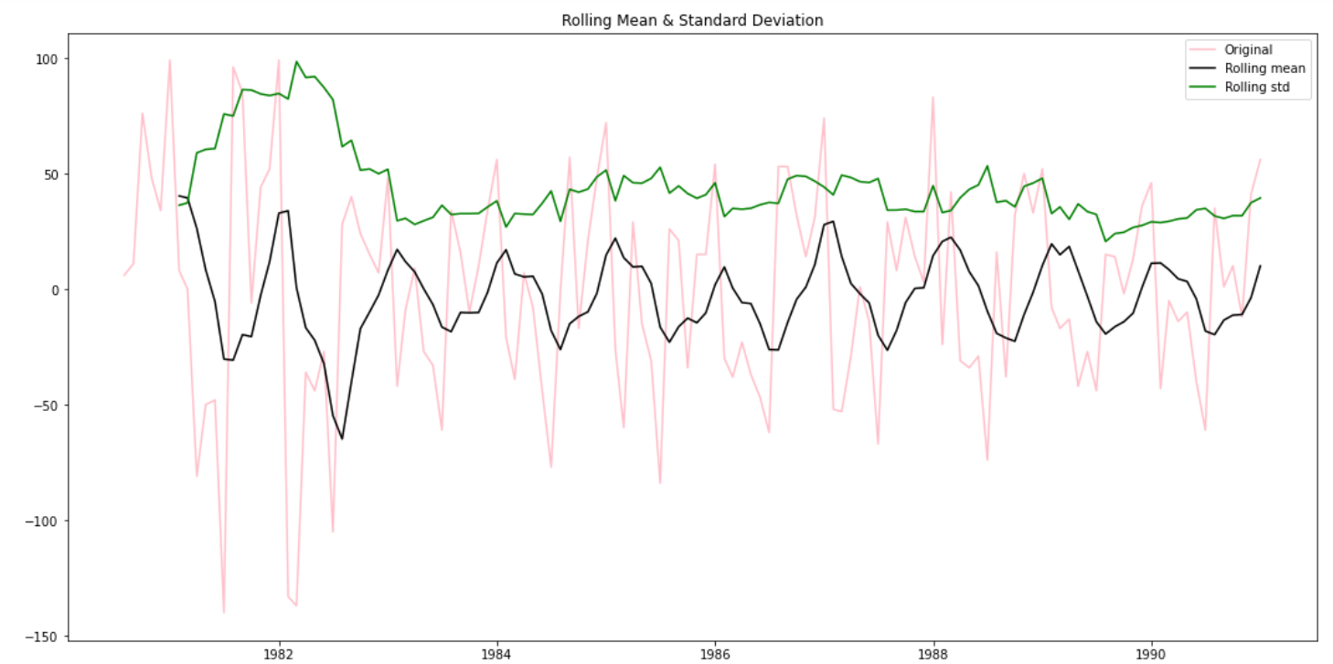

Plot for Auto correlation (ACF) on rose dataset with differencing of 6 and let see the cut off points:
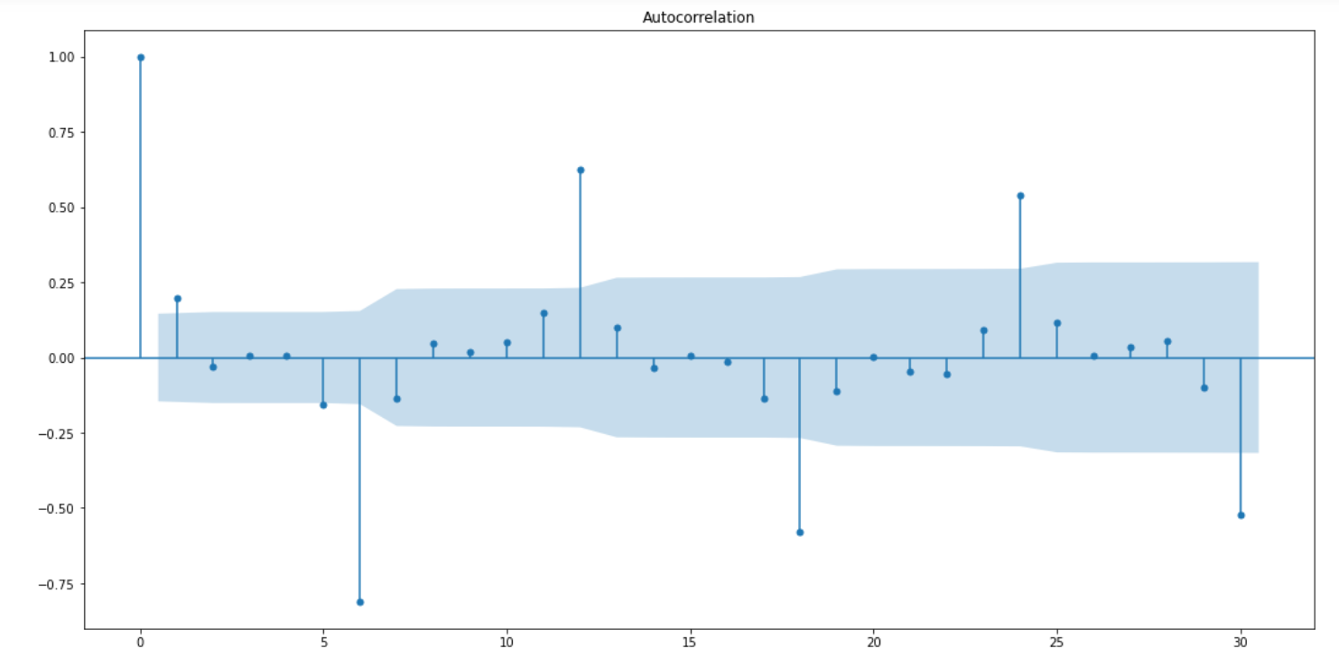

Partial Auto correlation (PACF):
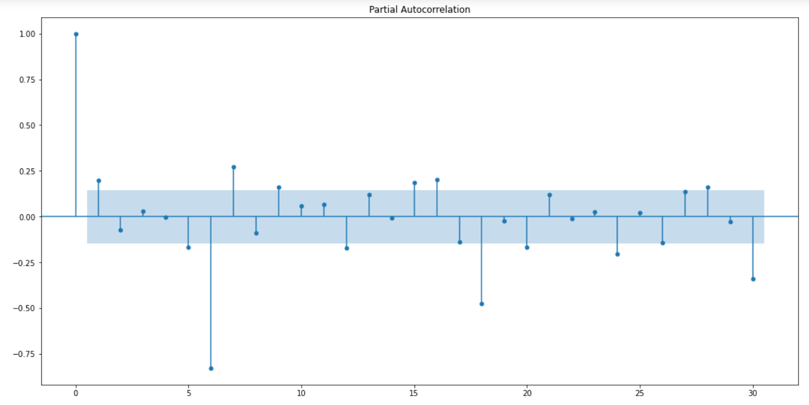
Now, both the ACF and PACF plots have the cut off at 1. Alpha value at 0.05. We will check the ACF and PACF plots at a multiple of 6, because seasonal period is 6.
SARIMAX model summary results for the order= (4, 1, 2), seasonal order= (1, 1, 1, 6)
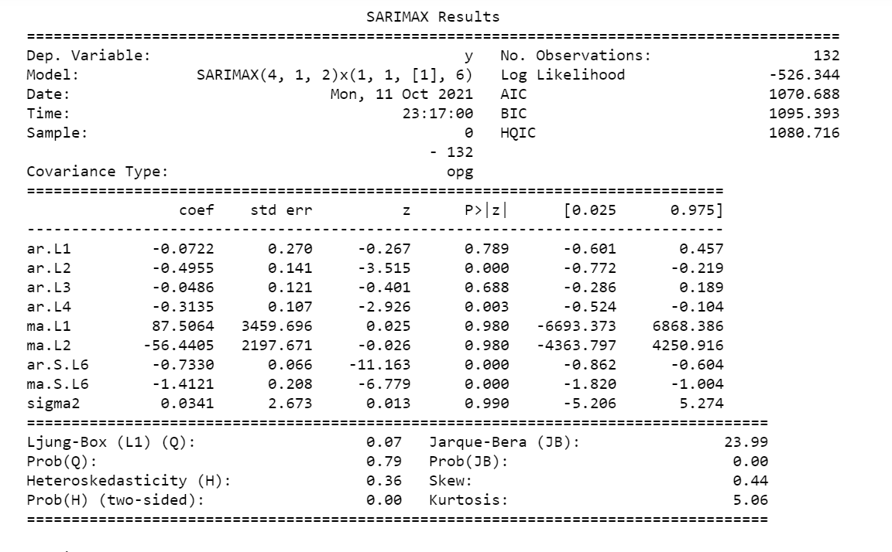
RMSE value calculation: 19.004805582081588
8. Build a table with all the models built along with their corresponding parameters and the respective RMSE values on the test data.
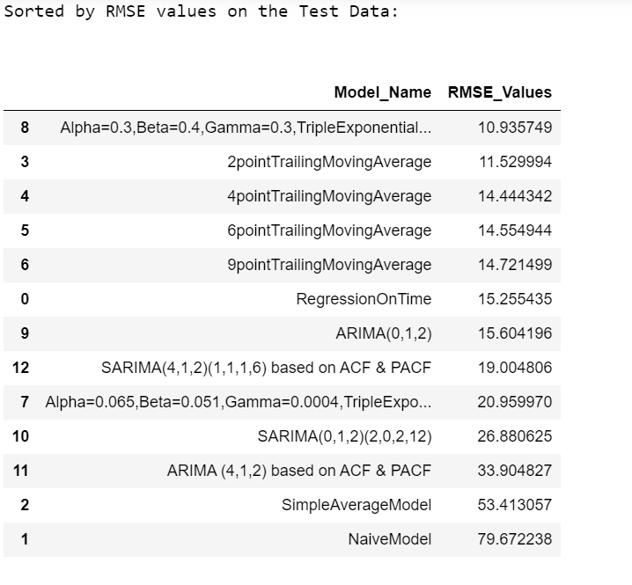
We can see that the Triple Exponential Smoothing with Alpha=0.3, Beta=0.4, Gamma=0.3, gives us the lowest RMSE value of 10.935749. So, this is the best model among all.

10. Comment on the model thus built and report your findings and suggest the measures that the company should be taking for future sales.

Some Measures that company need to take care of in future:
We have observed the sales pattern of rose wine from the year 1980 till 1995 and found out that few points that need to understand:
Fall in trend is clearly visible from yearly plot.
The maximum number of sales happened in the month of December due to some festive season and also because of the year end celebration, so we need to take care of all the arrangements for the customers by keep our stocks full at all point of sales center/shop.
We also need to take care of quality, the purity of material used to make the rose wine. This will definitely lead to advancement in sales
The lowest number of sales observed in the month of June.
We have built all the applicable models with our data and calculated RMSE values on all the test data.
After calculating RMSE, we got to know the Triple Exponential model is best for our data due to its lowest RMSE value.
We have also predicted the sales for upcoming 12 months with confidence interval.
Trend was affecting too much and not up to the mark as expected. So we also need to take care of the better quality of the wine to get the attention and attraction of the customers.
If we are able to take these above steps carefully then definitely our sales of the Rose wine would be more in upcoming future.

_____________________THE END_______________________________

